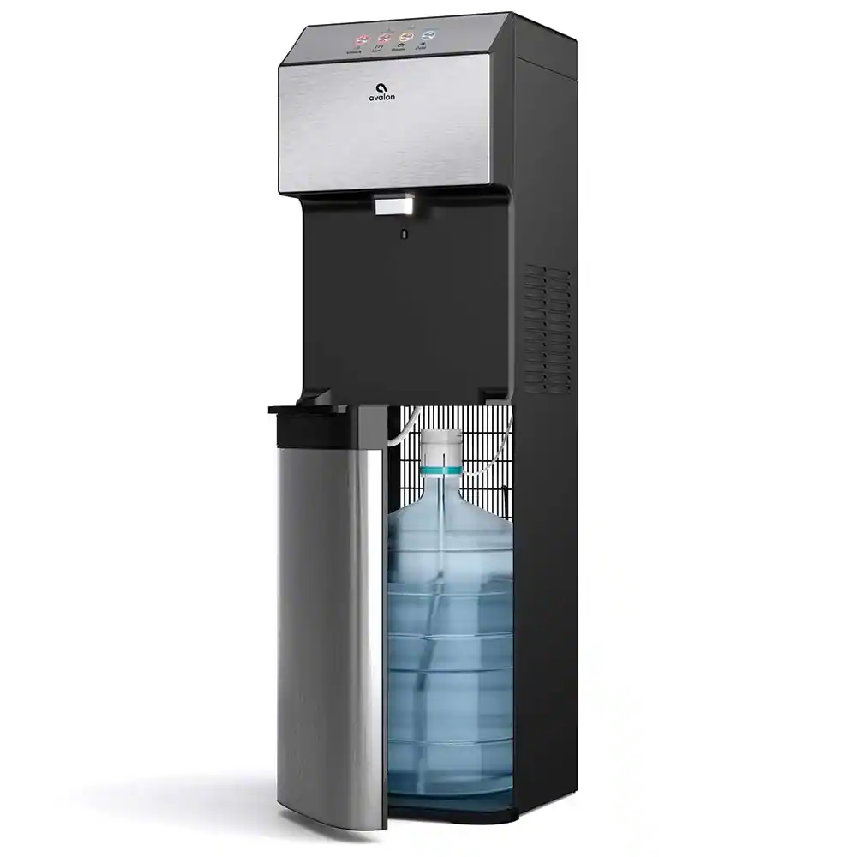

**Haier 4k full auto sdfgd dvf loaded Water dispenser**

* **Color:**white/grey
* **Available:**in stock
* **Dimension:**1641*595*600
* **Size:**19
* **Old Price:**~~Rs 44,000.00~~
* **New Price:**Rs 39,500.00